Introduce

Kit Model: CTR-30 (three-color light) / CTR-30C (Colorful light)
Operating voltage: DC4.5-5V
Power supply: 3 AA batteries or USB charger
Dimensions: 60mm * 136mm * 60mm (L*W*H)
CTR-30 flash Christmas tree kit consists of three circuit board, allows 36 LED flash alternately, showing a Christmas tree in the space of three-dimensional profile (the night environment has better viewing).

Production steps:

Step 1: Welding CTR-30A circuit board (referred to as A board)

- Soldering four resistors (R1 R3 R5 R7)

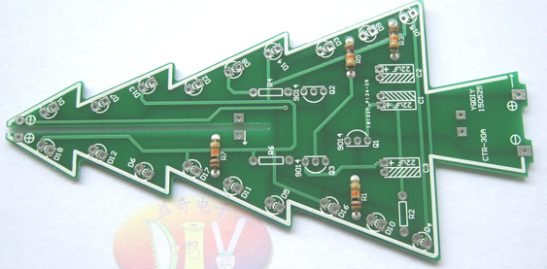

- Welding three resistance (R2 R4 R6)

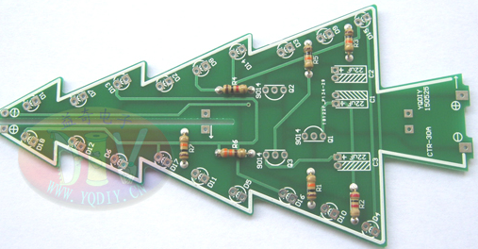

- Welding three transistors, with horizontal installation (with directions)

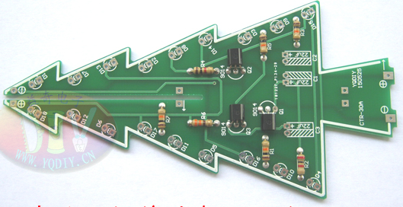

- Welding three electrolytic capacitors, use horizontal mounting (with direction)

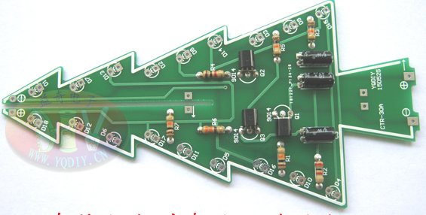

- Welding red LED (with direction)), the red LED numbered D1 ~ D6.

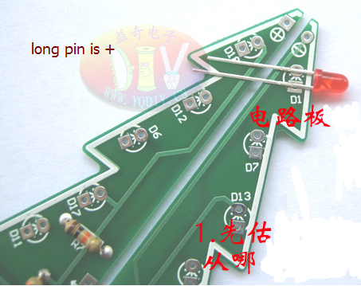

- After folded pin, inserted into the corresponding holes (note the mounting direction)

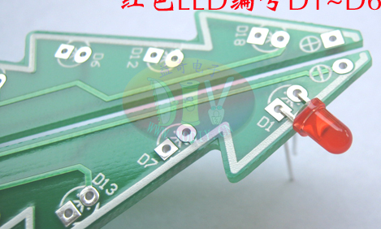

- The red LED welding finished (No. D1 ~ D6)

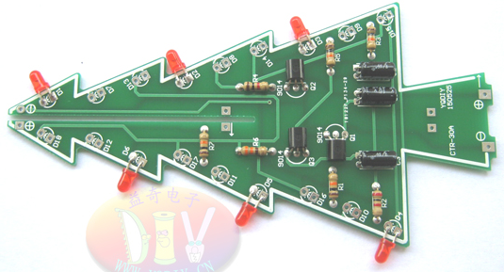

- Welding yellow LED (with direction), No. D7 ~ D12

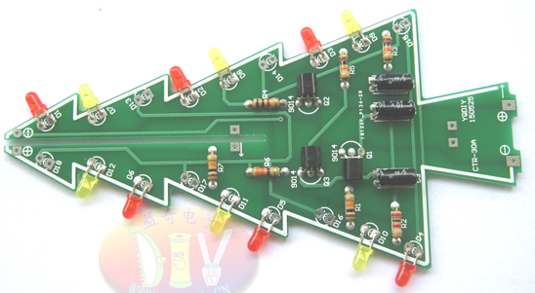

- Welding green LED (with direction), number D13 ~ D18

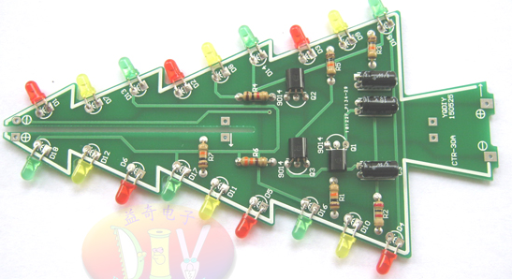

Now, A board welding finish.
Next using the same method welding CTR-30B circuit board , referred to as B board.

A board and B board has different mounting positions of the two elements:
1. R2 R4 R6 resistance has different mounting position
2. The red, green and yellow LED has different mounting position

- After A board and B board both are welding finish, you can power test whether two plates normal light flashes. A, B board need to continue normal flashing and continue the following step.

11. Welding CTR-30C circuit board, called C board
Welding a DC socket (with direction)

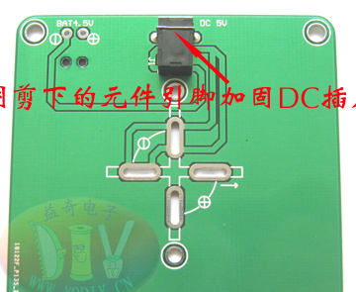
- Welding a key switch (with direction)
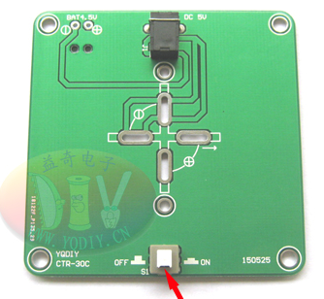

- A board and B board combination (with direction, the two plates are positioned like the arrow below), after two positioning arrows are aligned, use a soldering iron to put the two board together.

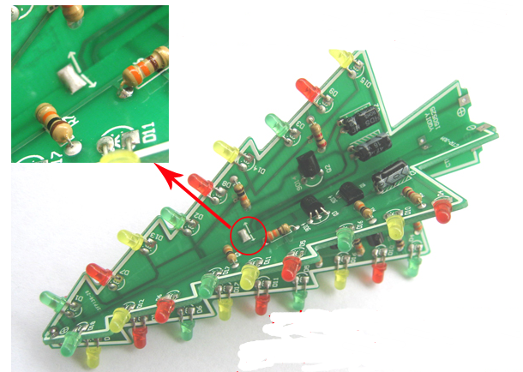

- Assembly the battery box and C board

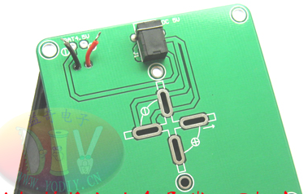
A. welding the wire battery case
B. fixed the battery case with screws and nuts

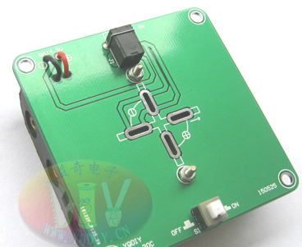
- Combination of A, B, C board (with direction)

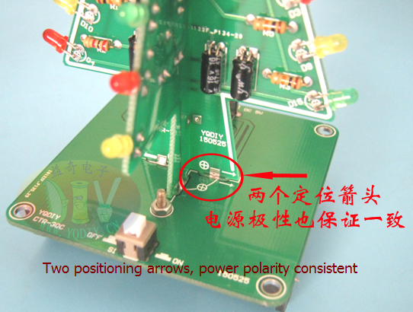

- Welding the top LED (with direction)

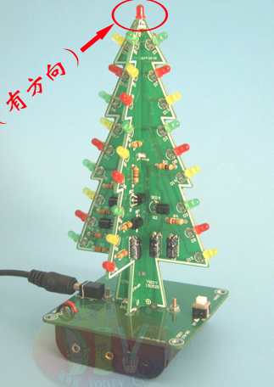

Congratulation!! You finish the kit!!
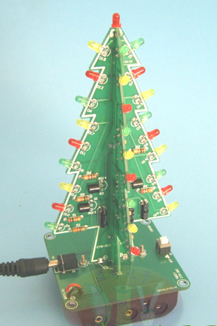 CTR-30 (three-color light)
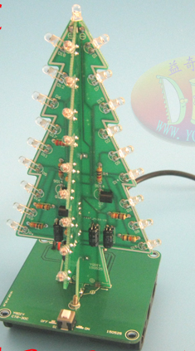 CTR-30C (Colorful light)

